.21 VZ-M Turbo

Turbo technology – in a marine engine!
It's the first-ever turbo engine for boat racers!
- The .21 VZ-M boasts a liner porting and inner head designed specifically for high nitro boat competition.
- Other high-performance features include a water-cooled plug cap and 2K flywheel.

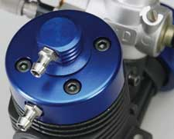  With the intake mounted directly on the plug, cooling water is channeled to the center of the head — the engine’s hottest point — before exiting. |  | 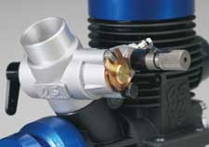  A big bore (10mm) on the 21D carburetor boosts power to the maximum.
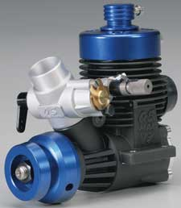
SPECIFICATIONS
Stock Number: OSMG1627
Displacement: 0.2 cu in (3.46cc)
Bore: 0.65 in (16.6mm)
Stroke: 0.63 in (16.0mm)
Practical RPM range: 3000-40,000
Power Output: 2.5 hp @ 33,000 rpm
Weight: 12 oz (340g)
Includes: P7 turbo plug

